

Foundations of Programming

saransh parihar-1262253066
div-11-k2

Assignment No.: 14
PROBLEM STATEMENT: Write a C program to input a binary number from the user and convert it into a decimal number.

OBJECTIVE:

- To understand number system conversions.
- To learn how to convert binary numbers to decimal numbers in C.
- To practice the use of loops and arithmetic operations.
- To develop logical thinking for number system problems.

THEORY:
A binary number system uses only two digits: 0 and 1. Each digit of a binary number represents a power of 2 depending on its position. To convert a binary number into its decimal equivalent, each digit is multiplied by 2 raised to the power of its position and the results are added together. In C programming, this conversion can be implemented using loops and arithmetic operations.

PLATFORM: Linux

INPUT: Binary number entered by the user.

OUTPUT: Displays the decimal equivalent of the given binary number.
SAMPLE INPUT:
Enter a binary number: 1011

SAMPLE OUTPUT:
Decimal equivalent = 11
CONCLUSION: Thus, the C program successfully converts a binary number entered by the user into its decimal equivalent using loops and arithmetic operations.

FAQs:
- What is a binary number system?
- How is a binary number converted into a decimal number?
- What is the role of loops in binary to decimal conversion?
- What is the role of the pow() function in this program?
- What is the data type used to store binary and decimal numbers in this program?

Code :
#include <stdio.h>
#include <math.h>

int main() {
int binary, decimal = 0, base = 1, remainder;

printf("Enter a binary number: ");
scanf("%d", &binary);

while (binary != 0) {
remainder = binary % 10; // get last digit (0 or 1)
decimal = decimal + remainder * base;
binary = binary / 10; // remove last digit
base = base * 2; // increase power of 2
}

printf("Decimal number = %d", decimal);

return 0;
}

Code screenshot :
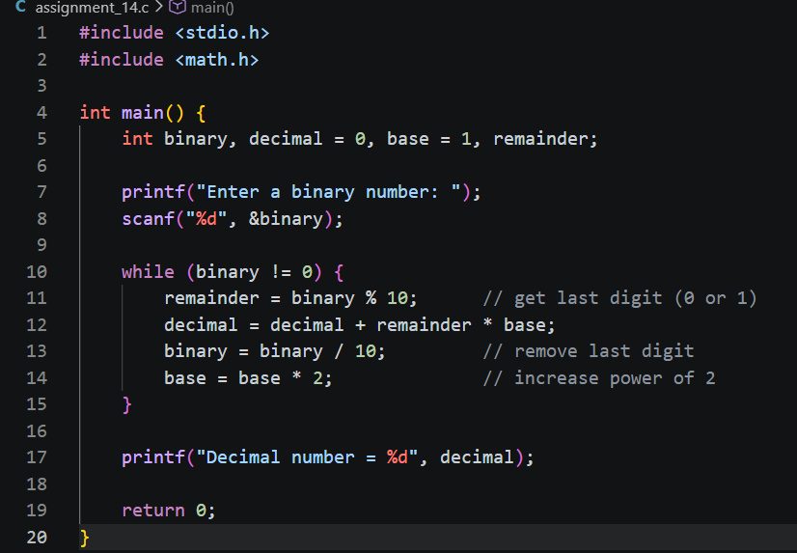

Output screenshot :
